
FACULTY OF TECHNOLOGY AND ENGINEERING
DEVANG PATEL INSTITUTE OF ADVANCE TECHNOLOGY
AND RESEARCH
DEPARTMENT OF COMPUTER ENGINEERING
A.Y 2026 – 27 Semester – 3
LAB MANUAL

CSUC201 Fundamentals of Data Structures and Algorithms

Practical 3: Sorting Algorithms: Comparison-Based,Counting-Based, and Digit-Based Strategies
Problem 1
A teacher has a stack of student answer sheets with marks written on them and needs to arrange them in order before entering grades. She tries three different methods: in the first, she repeatedly compares adjacent sheets and swaps them if they are out of order; in the second,she finds the lowest-marked sheet each time and places it at the front; in the third, she picks each sheet one by one and inserts it into its correct position among the already-arranged sheets. Implement all three methods and for each one, print the sorted order of marks.

Code :
Git hub link:
https://github.com/25DCS032/DSA-25dcs032
Out put screenshots:
- Bubble Sort
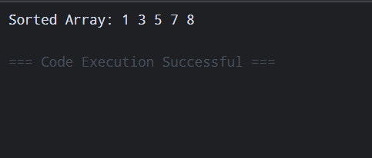
- Selection Sort
- Insertion Sort

Problem 2
A paint shop has buckets labeled with one of three colour codes — 0, 1, or 2 — but they are stored in a random order. The shop owner wants all 0s together, then all 1s, then all 2s, without using any extra storage. Given the list of colour codes, rearrange them in place and print theresult.
Describe the approach you used. Does your solution make more than one pass through the list?
Can you think of a way to do it in exactly one pass?

Code :
Git hub link:
25dce103_DSA_PJP_3CE2_B/practical-3 at main · nidhisavalia/25dce103_DSA_PJP_3CE2_B

Out put screensort:
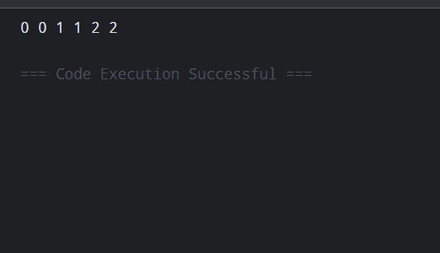
Challenges Faced
the use of three pointers (low, mid, high)

Learning Outcomes
the use of multiple pointers
array manipulation and swapping.

Key Questions / Analysis / Interpretation to be Evaluated During/After
Implementation
1. [Problem 1] One of the three methods can detect early that the list is already sorted and
stop without doing any more work. Which method is it, how would you add that
detection, and why can the other two not do the same?
Ans:
Bubble Sort can easily detect if the array is already sorted. If no swap happens in a complete pass, the array is already sorted, so Bubble Sort stops.
Selection Sort: It still searches for the minimum element in every remaining part.
Insertion Sort: It can also be efficient on an already-sorted array because no shifting is needed, but it doesn't use the same explicit swapped check.

2. [Problem 2] If your solution makes two passes through the list, can you identify which
decision in your logic forces the second pass? Is there a way to restructure that decision
to eliminate it?
Ans:
If we use Selection Sort, each outer-loop iteration searches the remaining array to find the minimum and then places it.
There isn't a simple decision we can remove to make standard Selection Sort a true one-pass algorithm, because finding the minimum requires checking the remaining elements.For Bubble Sort, however, the swapped check can stop unnecessary passes when the array becomes sorted.

